# SEO Analyzer Manual Guide

# V1.0

## By Cliff Mak

## 15 April 2018

# Introduction

This MVC application is a simplified SEO Analyzer that performs a simple SEO analysis of the text. User can provide a string input in English or page URL. The application filters out stop-words and calculates the number of occurrence on the input of each word, number of occurrences on the page of each word listed in meta tags; and number of external links in the text.

# Features and Snapshots

The landing page will be “../Home/Index”. There are 3 analysis options available, by default is checked. User can provide input in textual form or Url string.

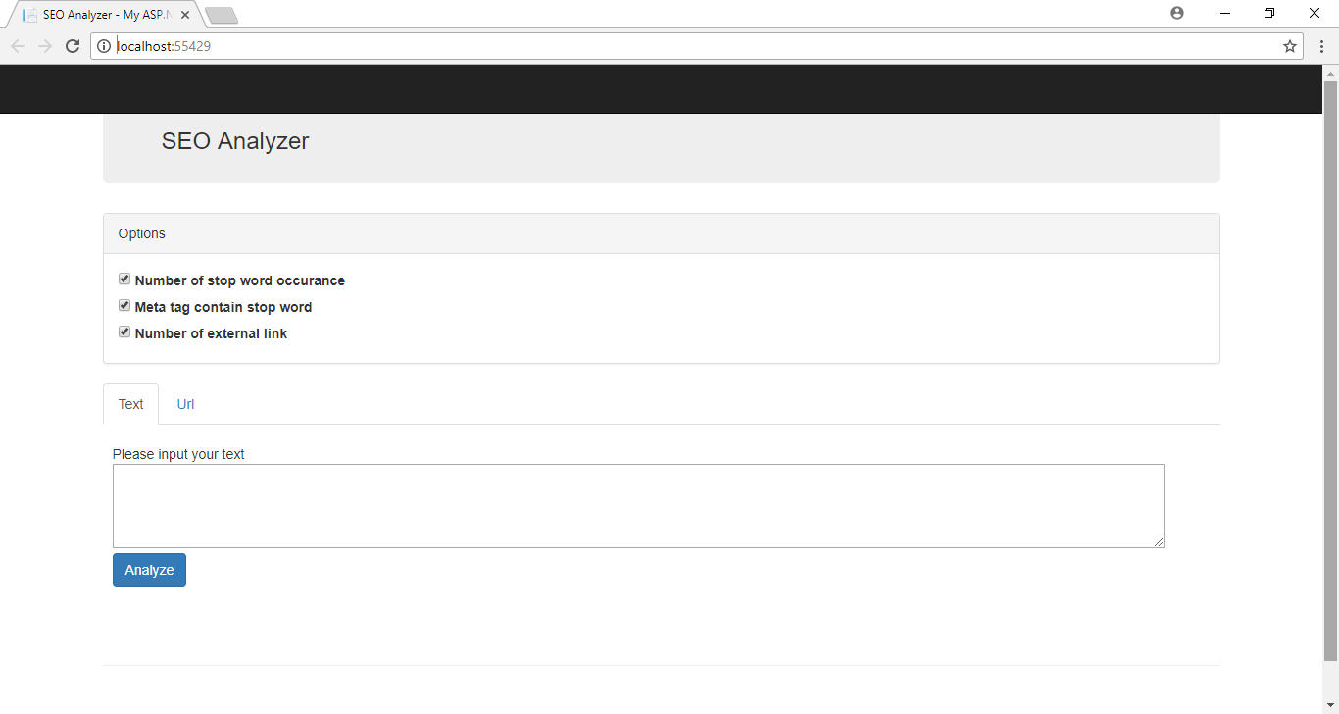

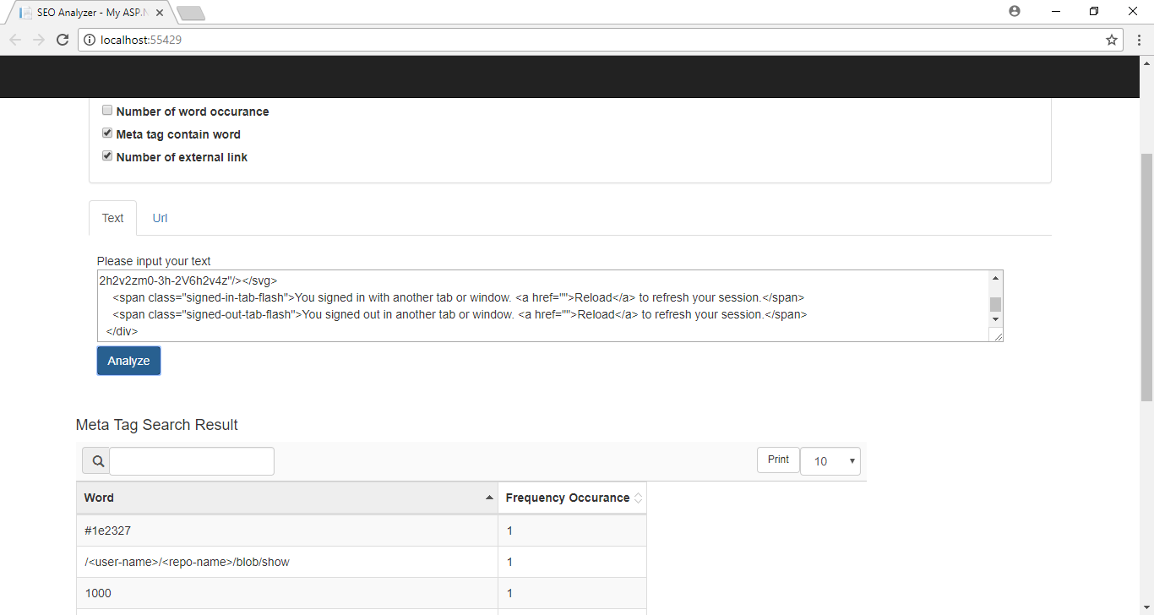

The result is in tabular format based on the analysis options selected. Each table is furnished with sorting, printing, normal searching and paging capability.

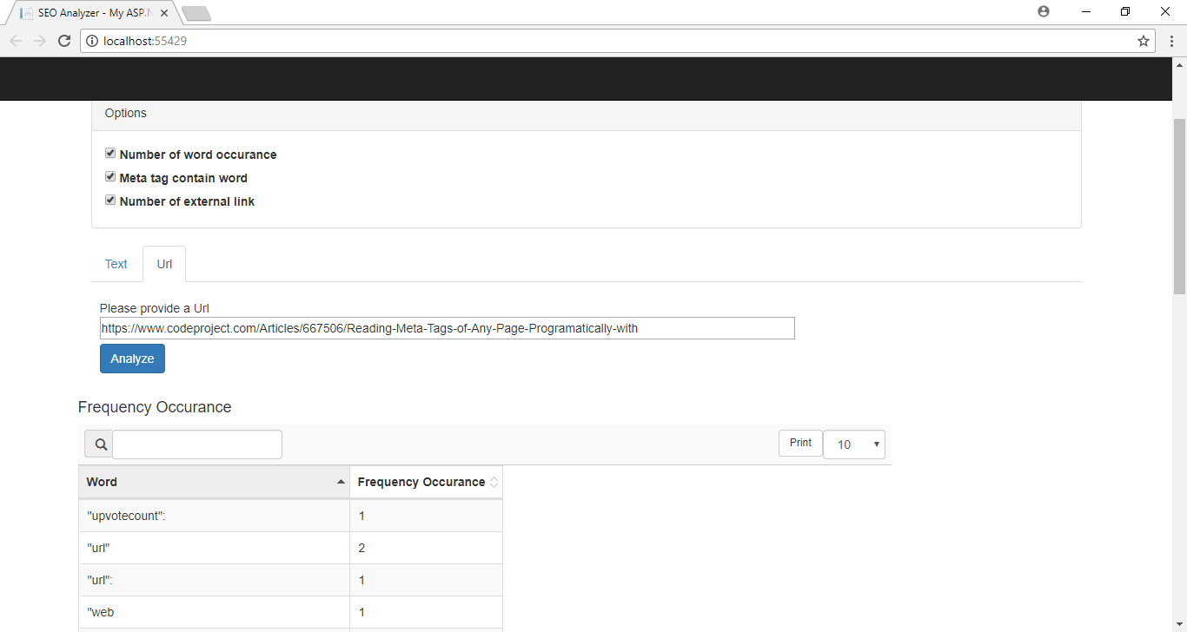

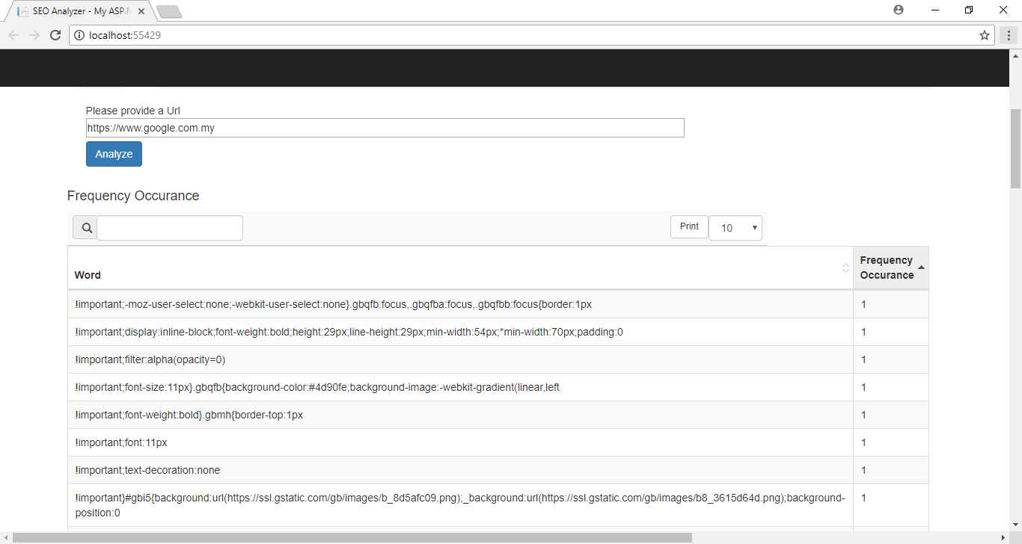

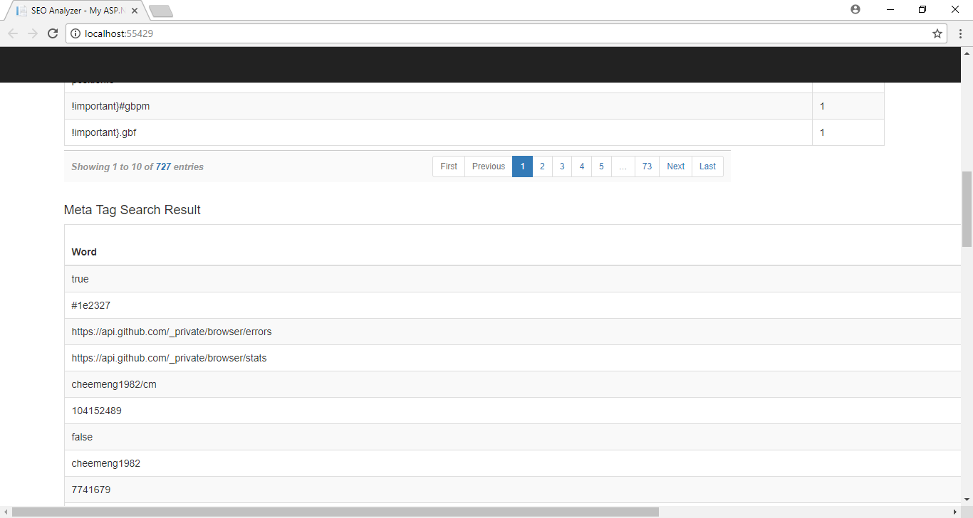

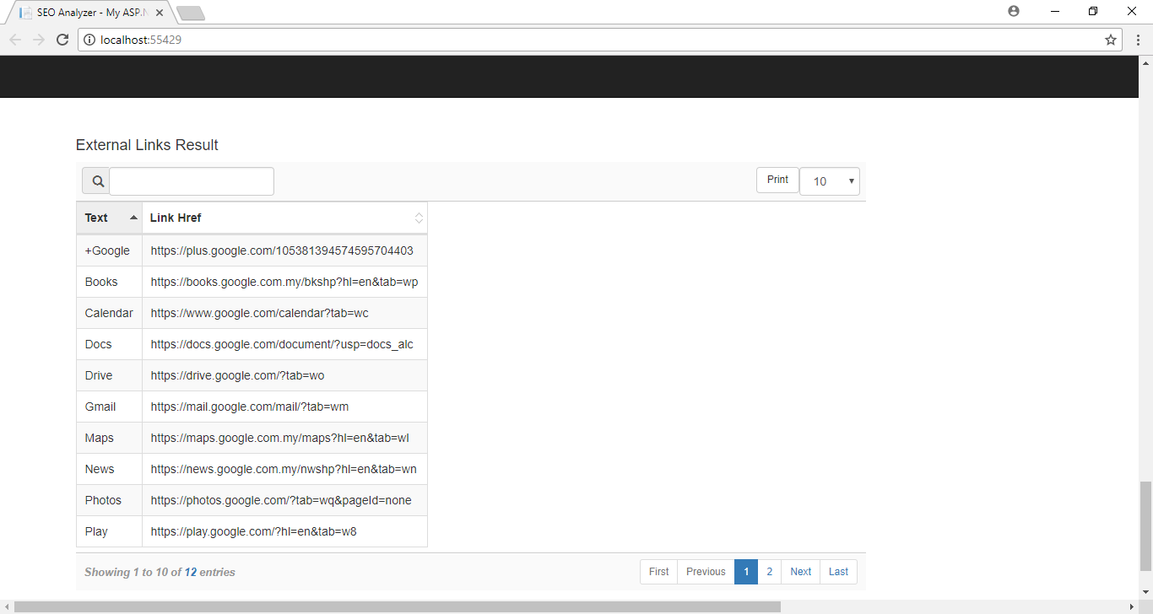

When user provides invalid input (such as invalid URL) or encountered communication exception, the notification panel is prompt with error message.

